**OUTREACH SCHOOLS EXAMINATION BOARD**

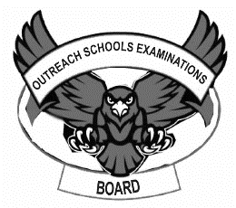 **BEGINNING OF TERM III EXAMINATION 2024**

**PRIMARY ONE**

**ENGLISH**

**My name is ___________________________________________**

**I am in ________________________________________________**

**My school is __________________________________________**

1. **Fill in the missing letters to complete the words.**
2. p____ppy (ii) ch____rch
3. p____nga (iv) ____mbrella
4. **Write in capital letters.**

Sunshine blanket

__________________________ ______________________

1. **Name these pictures.**

|  |  |  |
| --- | --- | --- |
|  |  |  |
| **KAKIRI JUNIOR SCHOOL**  **P.O BOX 239 KLA** |  |  |

(**school badge, school flag, school signpost**)

1. **Match these words to their opposites.**

bad tall

short big

small good

1. **Change the words in brackets to their plurals.**
2. The ___________________________ are eating food. (**boy**)
3. The dog gave birth to five ____________________ .(**puppy**)
4. Halima has good ____________________________. (**dress**)
5. Our baby has many ___________________________. (**doll**)
6. 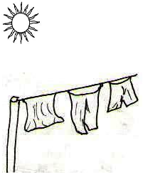**What is the weather now?**

It is _____________________ weather.

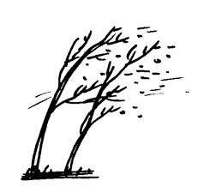

It is _____________________ weather.

1. **Complete the table.**

|  |  |  |
| --- | --- | --- |
| **Verb** | **Now tense** | **Yesterday tense** |
| Go | ……………………….. | Went |
| …………………….. | Coming | Came |
| …………………….. | Cooking | …………………….. |
| …………………….. | Playing | Played |

1. **Fill in “is” or “are” to complete the sentences correctly.**
2. We ___________________________ going to fetch water.
3. Daddy ________________________________ driving a car.
4. She ________________________________ washing utensils.
5. They _________________________________ playing football.
6. **Use ‘Yes, they are/ No, they are not**

Are these books?

______________________________

Are these banana leaves?

______________________________

 Are these hats?

______________________________

1. **Circle the odd word out**
2. book plate cup spoon
3. chair table stool stone
4. boy girl man snake
5. cow sheep basket goat
6. **Arrange these words in ABC order.**
7. girl, boy, cow

_________________________________________________________

1. orange, mango, apple

_________________________________________________________

1. h, w, f, d

_________________________________________________________

1. **Read the poem below use it and answer the questions that follow in full sentences.**

**Butterflies Butterflies Butterflies**

You are good insects

You have nice colours

Blue, yellow, black and white

People love your colours

**By Damalie**

**P.1 blue**

**Questions**

1. Write the insect in the poem.

_________________________________________________________

1. Write the colours of butterflies.

_________________________________________________________

1. Who wrote the poem?

_________________________________________________________

1. In which class is she?

_________________________________________________________

1. **Match animals to their young ones.**

cow baby

hen puppy

duck kid

pig calf

mother chick

goat duckling

dog piglet

***Good Luck***